|  |
| --- |
| **Software Test Plan** |

|  |  |
| --- | --- |
| Nr. : | 01 |
| Title: | OS Tick |

**Contents**

1. Test Specification Information 3

2. Module Test Cases 3

3. Integration Test Cases 3

4. Naming rules for functions 3

# Test Specification Information

|  |  |  |
| --- | --- | --- |
| **Date of issue (MM/DD/YY)** | **Test Developer** | **Revision & Description** |
| 02/09/214 | Sergio Pienda | 0.1 |
|  |  |  |
|  |  |  |
|  |  |  |
|  |  |  |
|  |  |  |

# Module Test Cases

|  |  |  |
| --- | --- | --- |
| **Test Case** | **ID** | **Status** |
|  | **0.1** |  |
| **Requirements covered** | | |
| 0.1,0.2,0.3,0.4,0.5,0.6,0.7 | | |
| **Test Procedure** | | |
| Set up the frequency of the output PA0 of the ECU to 500 Hz using the XTAL | | |
| **Expected Results** | | |
| Using an oscilloscope verify that the frequency of the ECU is set to 500 Hz. | | |
| **Actual Results** | | **Test Results** |
| The frequency of the output PA0 of the ECU is equal to 500 Hz. | | PASS |
| **Comments** | | |
|  | | |

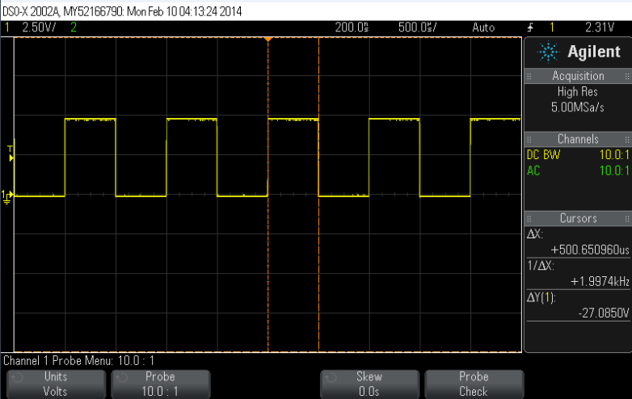

|  |  |  |
| --- | --- | --- |
| **Test Case** | **ID** | **Status** |
|  | **0.2** |  |
| **Requirements covered** | | |
| 0.1,0.2,0.3,0.4,0.5,0.6,0.7 | | |
| **Test Procedure** | | |
| Set up the frequency of the output PA0 of the ECU to 500 Hz using the Internal Oscillator of the ECU | | |
| **Expected Results** | | |
| Using an oscilloscope verify that the frequency of the ECU is set to 500 Hz. | | |
| **Actual Results** | | **Test Results** |
| The frequency of the output PA0 of the ECU is equal to 500 Hz. | | PASS |
| **Comments** | | |
|  | | |

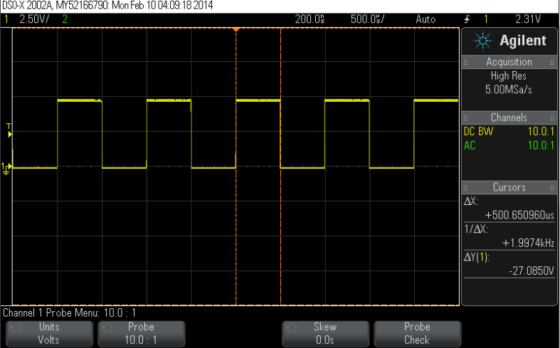

|  |  |  |
| --- | --- | --- |
| **Test Case** | **ID** | **Status** |
|  | **0.3** |  |
| **Requirements covered** | | |
| 0.1,0.2,0.3,0.4,0.5,0.6,0.7 | | |
| **Test Procedure** | | |
| Stop tick of the output PA4 and verify with the oscilloscope that the output is turned off | | |
| **Expected Results** | | |
| The voltage of the output PA4 is turned off. | | |
| **Actual Results** | | **Test Results** |
| The voltage of the output PA4 is turned off. | | PASS |
| **Comments** | | |
|  | | |

|  |  |  |
| --- | --- | --- |
| **Test Case** | **ID** | **Status** |
|  | **0.4** |  |
| **Requirements covered** | | |
| 0.1,0.2,0.3,0.4,0.5,0.6,0.7 | | |
| **Test Procedure** | | |
| Disable notification of the output PA3 and verify with the oscilloscope that the output is turned off | | |
| **Expected Results** | | |
| The voltage of the output PA3 is turned off. | | |
| **Actual Results** | | **Test Results** |
| The voltage of the output PA3 is turned off. | | PASS |
| **Comments** | | |
|  | | |

# Integration Test Cases

|  |  |  |
| --- | --- | --- |
| **Test Case** | **ID** | **Status** |
|  | **I.0** |  |
| **Requirements covered** | | |
| 0.1,0.2,0.3,0.4,0.5,0.6 | | |
| **Test Procedure** | | |
| Turn on the ECU and connect the output PA0 to an oscilloscope | | |
| **Expected Results** | | |
| Using an oscilloscope verify that there is a PWM working at a certain frequency | | |
| **Actual Results** | | **Test Results** |
| There is a PWM working at a certain frequency | | PASS |
| **Comments** | | |
| This test is going to be modified in further changes/Integration | | |